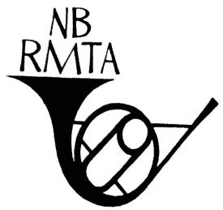

New Brunswick Registered Music Teachers’ Association
PRESS RELEASE
For immediate release
Local Music Teacher Receives National Recognition

Recipient Name receives the Hugheen Ferguson Distinguished Teacher Award!
The Canadian Federation of Music Teachers’ Associations recently honoured name of local recipient with the Hugheen Ferguson Distinguished Teacher Award at their biennial convention in city.
Include a brief bio of recipient and their contribution locally, provincially and nationally
Other recipients were: insert names, city, province and a one or two line description of each.
The Hugheen Ferguson Distinguished Teacher Awards honour deserving members of Registered Music Teachers’ Associations across Canada who have made significant contributions to the art of music and the profession of music teaching. Recipients are nominated by their peers. These awards were created in memory of the late Hugheen Ferguson, whose estate gifted the CFMTA with $5,000. Hugheen, CFMTA president from 1997-1999, was an extraordinary teacher, administrator and supporter of the Association and the arts throughout her lifetime.
For more information on the Hugheen Ferguson Distinguished Teacher Award or information on how to nominate a peer, please contact Pat Frehlich professionaldevelopment@cfmta.org

For more information on the NB recipient, please contact local president and email address or phone number
For more information on the New Brunswick Registered Music Teachers’ Associations and its projects, please visit www.nbrmta.com
For more information on the Canadian Federation of Music Teachers’ Associations and its projects, please visit www.cfmta.org
Source: Barbara Long
President
New Brunswick Registered Music Teachers’ Association
506.375.6752

The New Brunswick Music Teachers’ Association 11119 Route 130, Somerville NB Canada E7P 2S4

