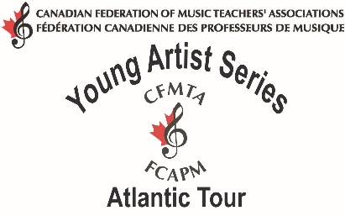

Canadian Federation of Music Teachers’ Association
PRESS RELEASE
For immediate release
Atlantic Young Artist Performs

Cityhosted theAtlantic Young Artist
The location was the venue for an exciting concert by nineteen year-old violinist, Heemin Choi as part of his seven-city Young Artist Tour throughout the maritime provinces.
Insert brief, description and review of program and name accompanist
Last spring, Winner Name was chosen from nine accomplished competitors at the Atlantic Young Artist Competition to perform as the 2012 AtlanticYoung Artist.
Recognize any donors or sponsors.
Insert brief bio info of performer
Insert info about remaining tour concerts in the area.
The Atlantic Young Artist Competition and Tour are projects of the Canadian Federation of Music Teachers' Associations and its provincial counterparts in New Brunswick, Nova Scotia, Newfoundland and Prince Edward Island. The competition is open to pianists, singers and instrumentalists who are currently studying with a Registered Music Teacher.

For more information on the Young Artist Series please visit www.cfmta.org

For more information on the Canadian Federation of Music Teachers’ Associations and its projects, please visit www.cfmta.org

