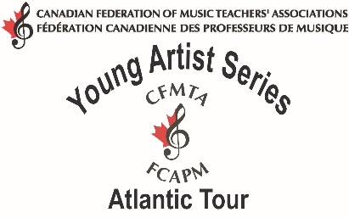

Canadian Federation of Music Teachers’ Association
PRESS RELEASE
For immediate release
Atlantic Young Artist Concert Announced

Cityto host the Atlantic Young Artist
The public is invited to the location, date for an exciting concert by nineteen year-old violinist, Heemin Choi as part of his seven-city Young Artist Tour throughout the maritime provinces.
Insert brief, description of program and name accompanist
Last spring, Winner Name, was chosen from nine accomplished competitors at the Atlantic Young Artist Competition to perform as the 2012 Atlantic Young Artist.
Insert Concert information – date, location, time, ticket price, where to buy tickets and contact person for each concert. Recognize any donors or sponsors.
Insert brief bio info of performer
The Atlantic Young Artist Competition and Tour are projects of the Canadian Federation of Music Teachers' Associations and its provincial counterparts in New Brunswick, Nova Scotia, Newfoundland and Prince Edward Island. The competition is open to pianists, singers and instrumentalists high calibre who are currently studying with a Registered Music Teacher.

For more information on the Young Artist Series please visit www.cfmta.org

For more information on the Canadian Federation of Music Teachers’ Associations and its projects, please visit www.cfmta.org

