The Name of Provincial Music Teachers’ Association [NBRMTA] is granted the right to publish and use any photographs and to exhibit audio or video in which I or my works appear for the purposes of NBRMTA’s archives, marketing, publicity and public relations projects.

__________________________________________________ ___________________

Signature Date

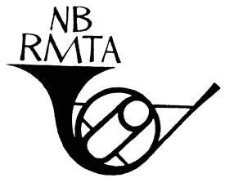

The Name of Provincial Music Teachers’ Association [NBRMTA] is granted the right to publish and use any photographs and to exhibit audio or video in which I or my works appear for the purposes of NBRMTA’s archives, marketing, publicity and public relations projects.

__________________________________________________ ___________________

Signature Date



The Name of Provincial Music Teachers’ Association [NBRMTA] is granted the right to publish and use any photographs and to exhibit audio or video in which I or my works appear for the purposes of NBRMTA’s archives, marketing, publicity and public relations projects.

__________________________________________________ ___________________

Signature Date

