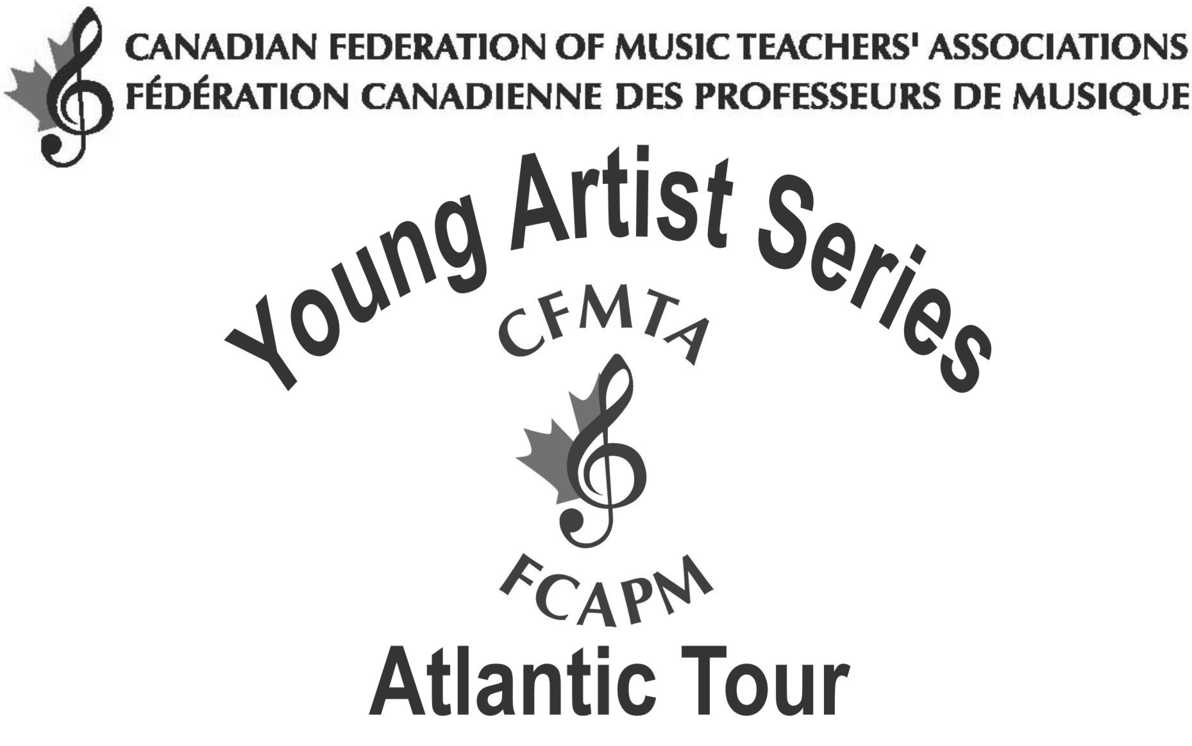

The Atlantic Young Artist Competition and Tour is a project of the Canadian Federation of Music Teachers’ Associations and its provincial counterparts in New Brunswick, Nova Scotia, Newfoundland and Labrador and Prince Edward Island. The competition is open to pianists, singers and instrumentalists who are studying with a Registered Music Teacher and who are residents of the Atlantic Provinces or are studying in the Atlantic region. A biennial event, the Competition for the Atlantic Region takes place in the spring, with the Tour in the fall.
The Young Artist Series was initiated in 1942 under the direction of Saskatchewan music educator Dr. Lyell Gustin, in order to give talented young performers an opportunity to gain concert tour experience. The Young Artist Series now operates in five regions of Canada: Atlantic, Ontario, Western, British Columbia, Alberta.
Many Young Artist soloists, who had their first major concert experience through the Series, have gone on to make careers in music. Our Atlantic Young Artist winners have included:

1985 Michelle Beaton, piano (NS)
1986 Donald Fraser, organist (PEI)
1987 Vicki MacNutt, voice (NS)
1989 Deborah Pardy, piano (NL)
1991 Jonathan Weiser, piano (NL)
1993 Thomas Yee, piano (NL)
1995 David Sharpe, piano (ON, studied NB)
1997 Measha Gosman, voice (NB)
and Mark Barter, piano (NL)
1999 Lynn Kuo, violin (NL)
2001 Marc Djokic, violin (NS)
2003 Patrick Cashin, piano (NL)
2006 Philip Roberts, piano (NL)
2008 Michael Thibodeau, piano (NS)
2010 Pierre-André Doucet, piano (NB)
2012 Heemin Choi, violin (NS)

Local Branch Music Teachers’ Association

and the

Canadian Federation of Music Teachers’ Association

present the

Location Young Artist Concert

Heemin Choi, violin
Lynn Stodola, piano

Date
Time

Venue
City, Province

Other Concert Dates:

October 4 Sackville, NB
October 5 Charlottetown, PE
October 14 Yarmouth, NS
October 17 Halifax, NS
October 21 Fredericton, NB

PROGRAM / PROGRAMME

Sonata No. 1 in D Major, op. 12 Ludwig van Beethoven
1. Allegro con brio
2. Tema con variazioni: Andante con moto
3. Rondo: Allegro

Cantabile MS 109, Op. 17 Nicolo Paganini
Violin Concerto No. 2 in B minor, Op. 7
Rondo “La Campanella"

-Intermission-

Sonata for Unaccompanied Violin Richard Mascall
V. "At The Corner House"

Sonata in E-flat Major, Op. 18 Richard Strauss
1. Allegro, ma non troppo
2. Improvisation: Andante cantabile
3. Finale: Andante – Allegro

Competitor bio

Accompanist bio

